**//FAISAL RASOOL QAZI**

**//455689**

**//ME 15 SEC-B**

**//FOP 04 HOME TASKS**

**//TASK 01**

#include <iostream>

using namespace std;

int main(){

for(int i=1; i<=150; ++i)

if(i%10 !=0)

cout<< i <<" ";

}

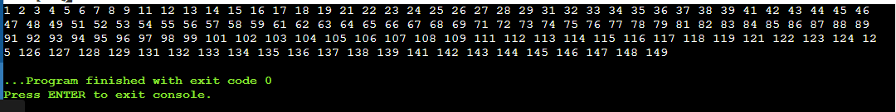

**//TASK 02**

#include <iostream>

using namespace std;

int main() {

int num, sum = 0;

cout << "Enter a number: ";

cin >> num;

while (num > 0) {

int digit = num % 10;

sum += digit;

num /= 10;

}

cout << "Sum of digits: " << sum << endl;

return 0;

}

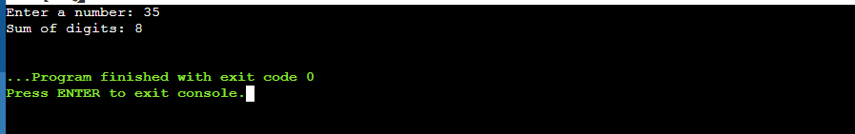

**//TASK 03**

#include <iostream>

using namespace std;

int main()

{

int n, i, m=0, x=0;

cout<<"Enter a Number: ";

cin>>n;

m=n/2;

for(i=2; i<=m; i++)

{

if(n%i==0)

{

cout<<"This integer is not Prime."<<endl;

x=1;

break;

}

}

if (x==0)

cout << "This integer is Prime."<<endl;

return 0;

}

